Select New Member: Sign Up
  - Join today - fill in the blank fields.
  - Make sure you remember your Account Details as you will need these when you log back into your account.
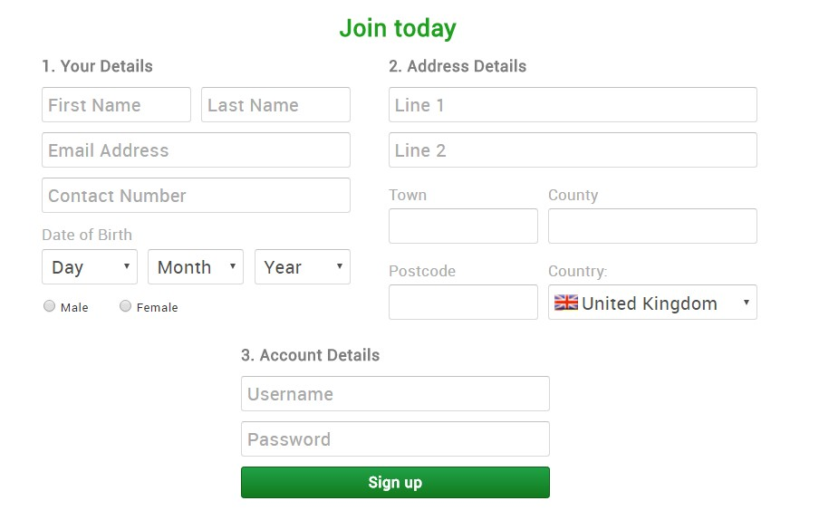

  - You must select a swim club, or the club will not see you have registered as a member.
  - To select which club you are a member of
    - Click on - My Clubs - Select Club

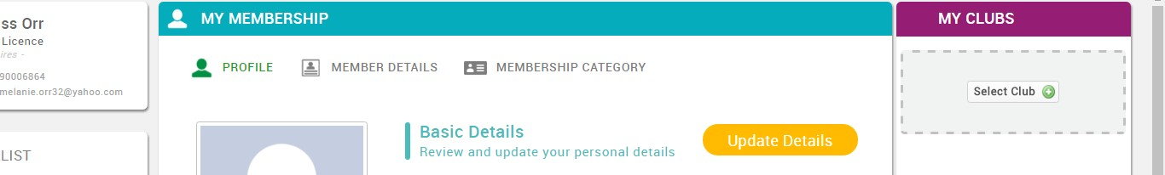

    - To find the club – in Club Finder - type in the Club or Swim School, click Search and select the List view. Alternatively, you can search within a distance of your postcode to find your club.
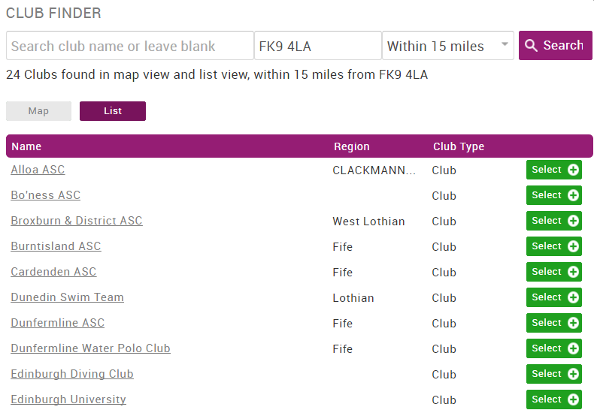

- Once you have selected your club, the Club or Swim School will receive a notification that you wish to join and will approve the membership. The club will then pay for the membership direct to Scottish Swimming from the annual membership fee you have paid to Warrender Baths Club
- You should then update all your personal details to ensure the Scottish Swimming database is accurate and that clubs/Swim Schools have the correct details for you. (see instructions on the following pages)
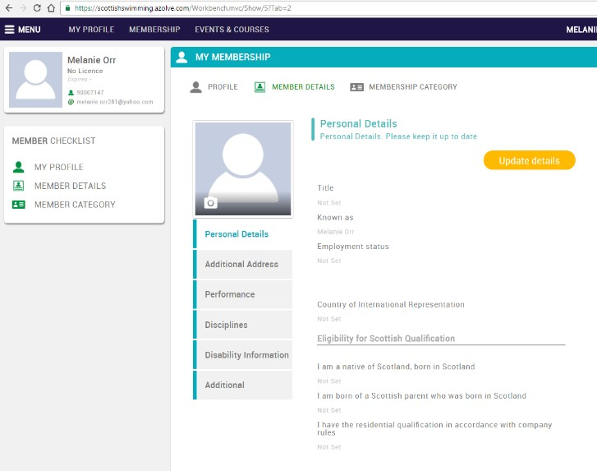
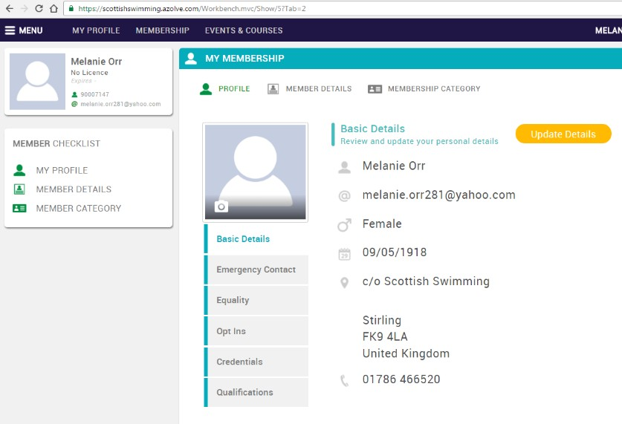

Family Module – Adding Family Members on to the System

Why use the family module?
The family module allows members to be grouped together as a family. This allows a member to log into one account, but see all family members together on the system. Also it means one email address can be used for multiple users. Each member’s basic profile details (eg contact details) can be changed from logging in just once. However to change more detailed information for example disciplines, etc., each member needs to login to their own individual account.
These instructions only apply when you are adding new members to a member who already exists on the database. If you would like to create a group of family members who already exist on the system, please contact info@scottishswimming.com detailing which members you would like grouped together and we will do it for you.
How to Add New Family Members:
- Log into the main user at www.scottishswimmingmembers.com (for help logging on go to page 5)
  - Click on ‘Membership Category’
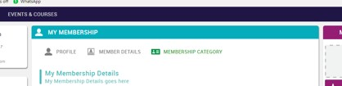

  - Click on ‘Add a Family’
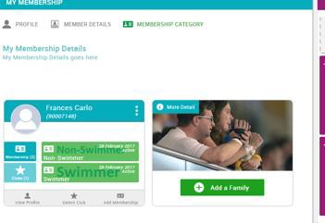

  - Type in a family name and click on ‘Done’
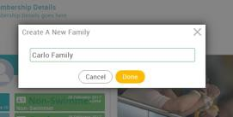

  - Add in the new member’s basic details and MAKE SURE you click on ‘Save’ at the top
  - As you add in new members it will automatically transfer over your email address. You can manually change this if you like, or leave the same to avoid receiving the same email to different email addresses.
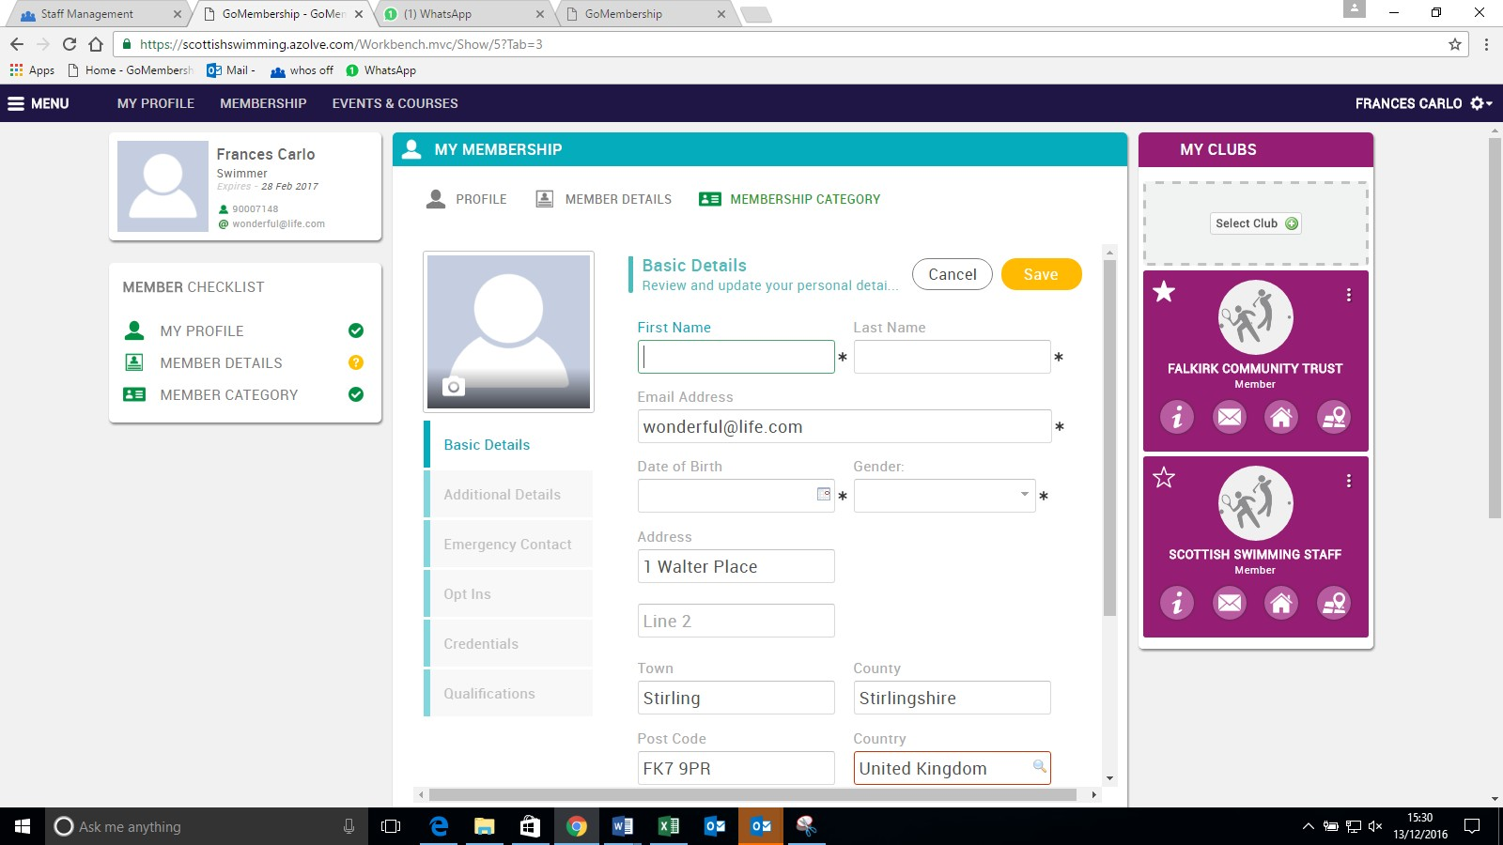

- You will then see the family member on your screen. Make sure you select a club, which will then go to the club secretary for approval.

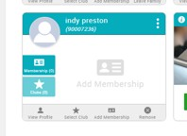
- To select club the list is the easiest way to find a club – enter your postcode and click list – then click to select a club or swim school – this will be submitted to the club secretary for approval.
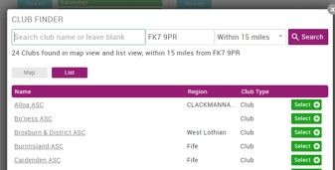

- To add more members to the same family, click add new family member and return to page 11.
